**Expt-1**

Problem statement - Write a program for default passwords, printed passwords and password in plain text form. Draw flowchart, algorithm and attach output results for the same.

1. Explain RSA algorithm in detail with example.
2. Explain any two of following with example
   1. Playfair Cipher
   2. Hill Cipher
   3. Vigenère cipher
   4. One-Time Pad cipher
   5. Monoalphabetic cipher
3. Compare in Tabular fashion, Confidentiality, Integrity, Authentication and Non repudiation for following security techniques
4. Classical Encryption/Decryption
5. Symmetric Encryption
6. Asymmetric Encryption
7. Hashing Technique
8. MAC technique
9. Digital Signature System

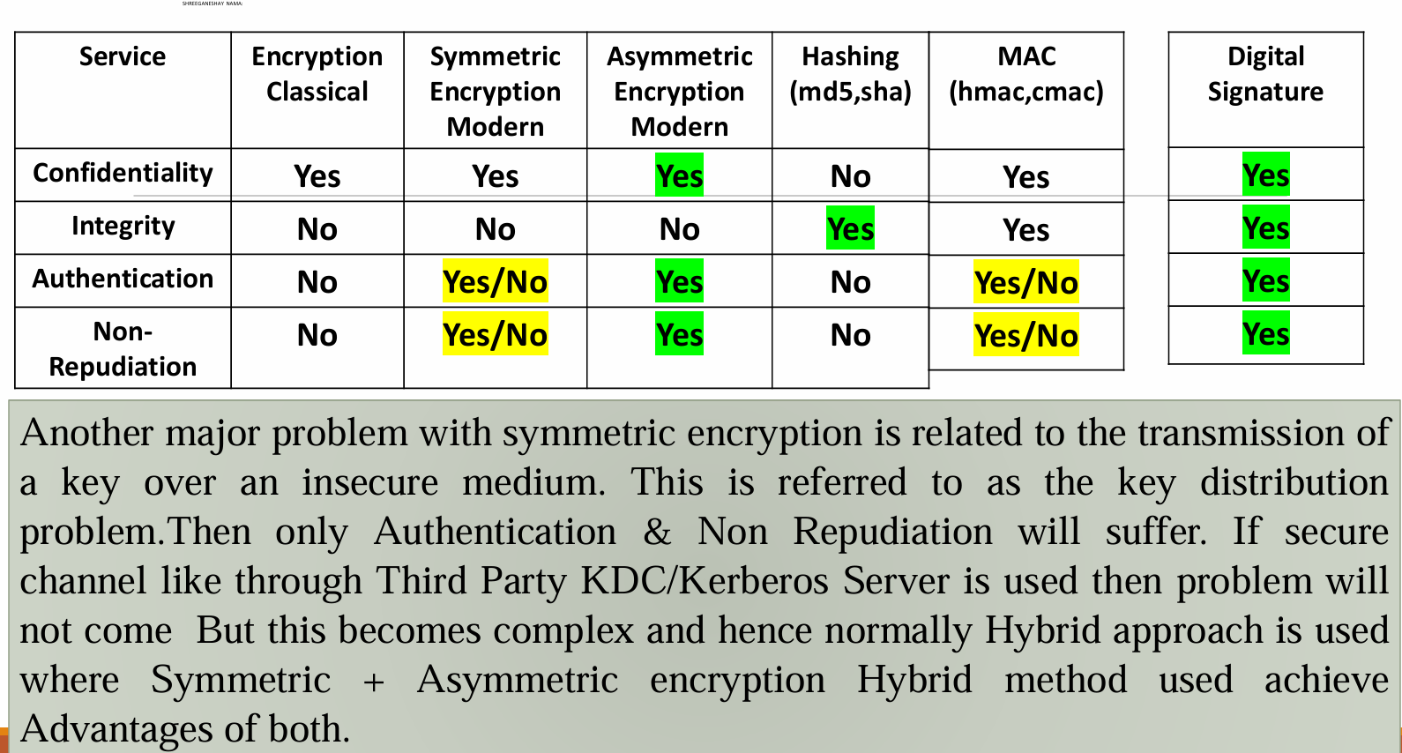

1. Explain DES algorithm in detail.
2. Compare classical Vs Modern Cryptography.

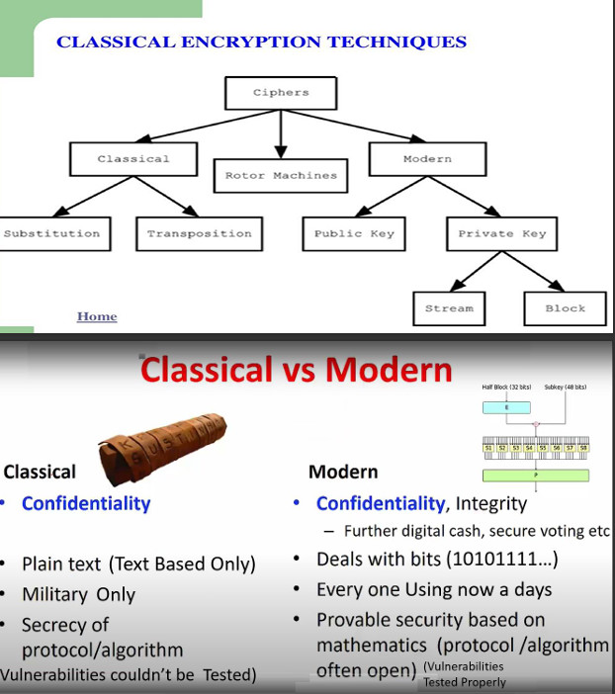

1. What is DoS attack? What is DDoS attack? How to Mitigate it?

**Expt -2**

Problem statement- Write a program of encryption and decryption for transposition cipher. Draw flowchart, algorithm and attach output results for the same.

1. Use key
2. MEGABUCK, or
3. PICTENTG, or
4. NBAISOKR
5. for message: please transfer one million dollars to my swiss bank account six two two four
6. Explain C, I, A, Authentication and Non-Repudiation.
7. Explain the Interruption, Interception, Modification and Fabrication attack. Corelate the said attacks with C,I,A, Authentication and Non-Repudiation.

**Expt -3**

Problem Statement - Write a program of encryption and decryption for Substitution Cipher-Caesar Cipher. Draw flowchart, algorithm and attach output results for the same.

1. Use key
2. 3, or
3. 5, or
4. 7
5. for message: please transfer one million dollars to my swiss bank account six two two four

**Expt - 4**

Problem Statement - Demonstrate installation and configuration of mobile Security app. Explain the different features and record the different working snapshots for the same.

1. What is WEP and WAP security techniques? Explain the details.
2. What are the different wireless components used for Wi-Fi, Bluetooth Communications?
3. Write details about ISM band frequencies, BT standards & Wi-Fi standards.
4. Compare symmetric and asymmetric key cryptography.(Min 8 Points).

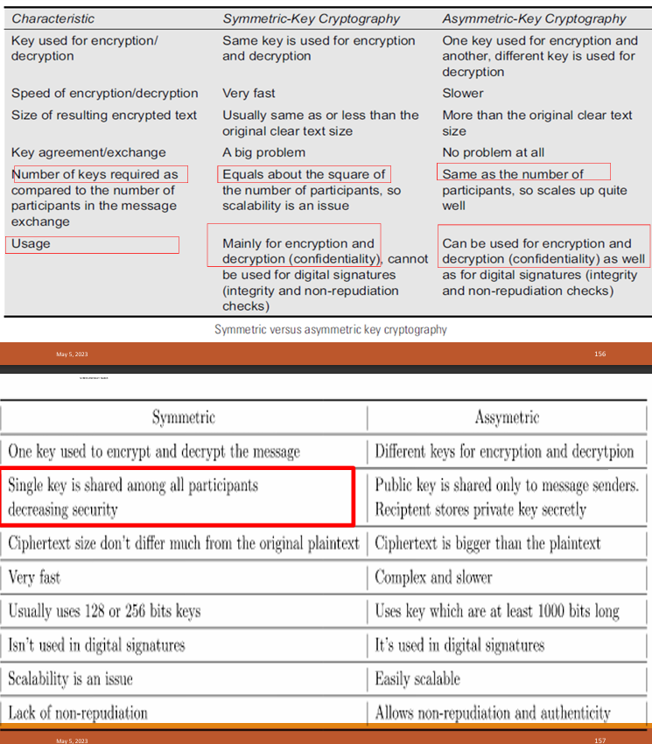

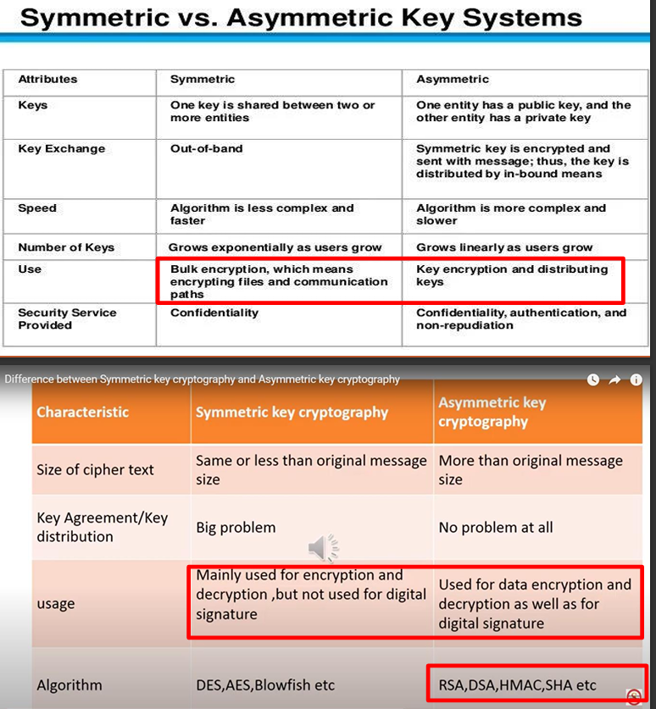

1. Draw and explain how DES algorithm works in detail.
2. Explain Transport and tunnel mode in IPSec.

**Expt - 5**

Problem Statement - Demonstrate installation and configuration of Steganography technique in view of network security. Explain the different features and record the different working snapshots for the same.

1. Draw and explain the block diagram of Steganography for Image as data.
2. Compare Steganography versus Cryptography.
3. Draw and explain the following block diagrams
4. Digital Signature system.

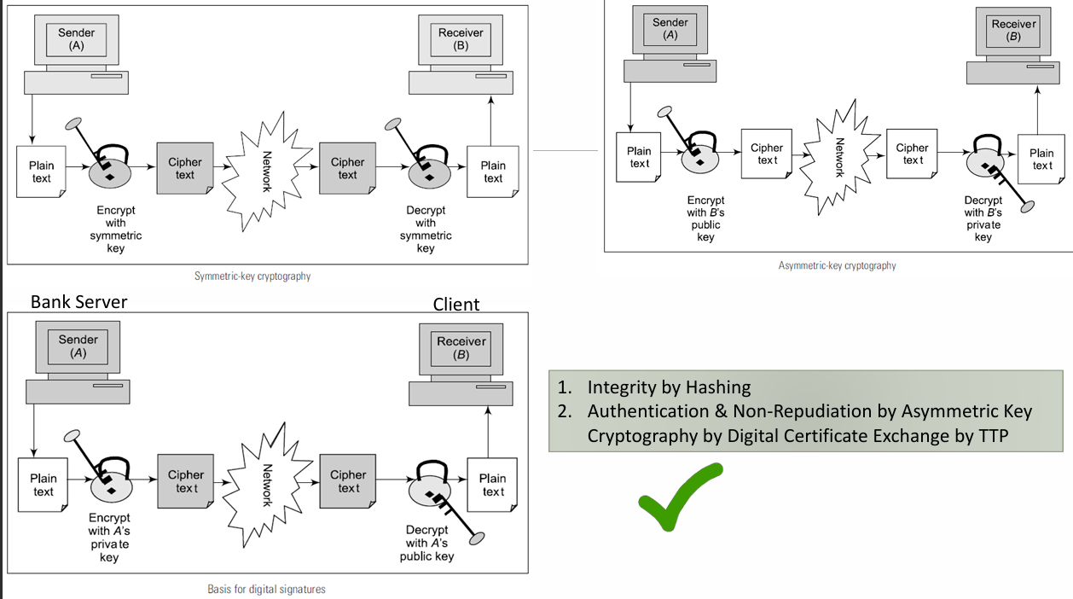

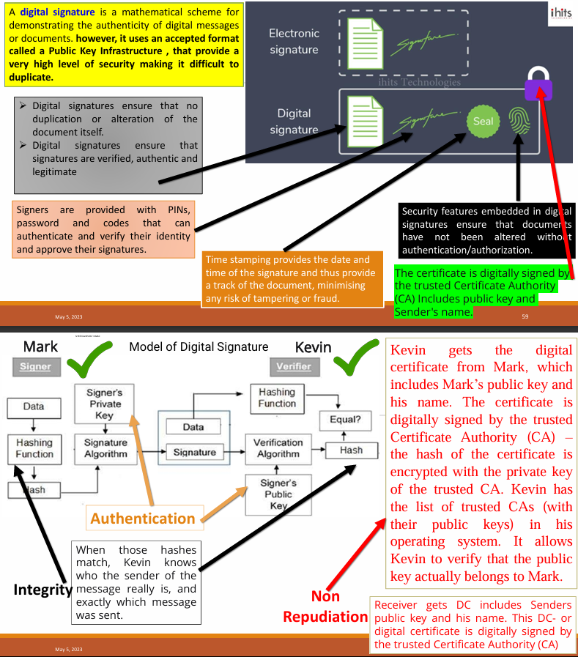

1. End to End Email Communication system with Hashing, Digital signature and Digital Envelope processing blocks.

**Expt - 6**

Problem Statement - Install and configure firewall for Host security. Explain the different features and record the different working snapshots for the same.

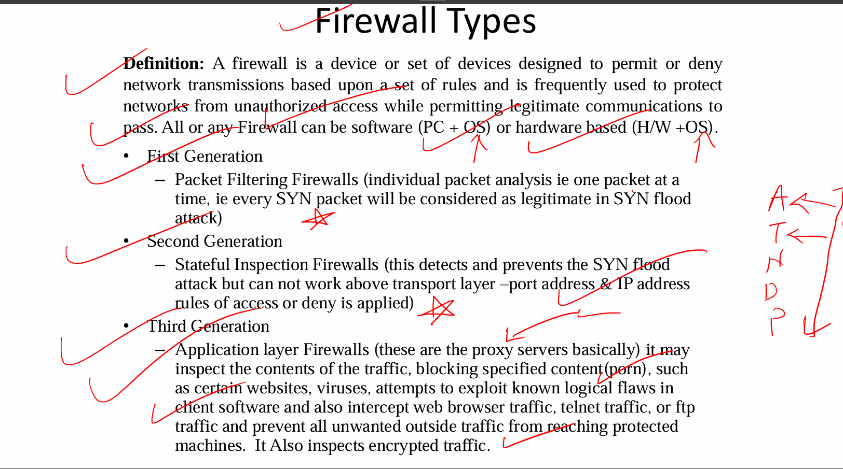

1. Draw and explain following. A)Packet filtering firewall
2. 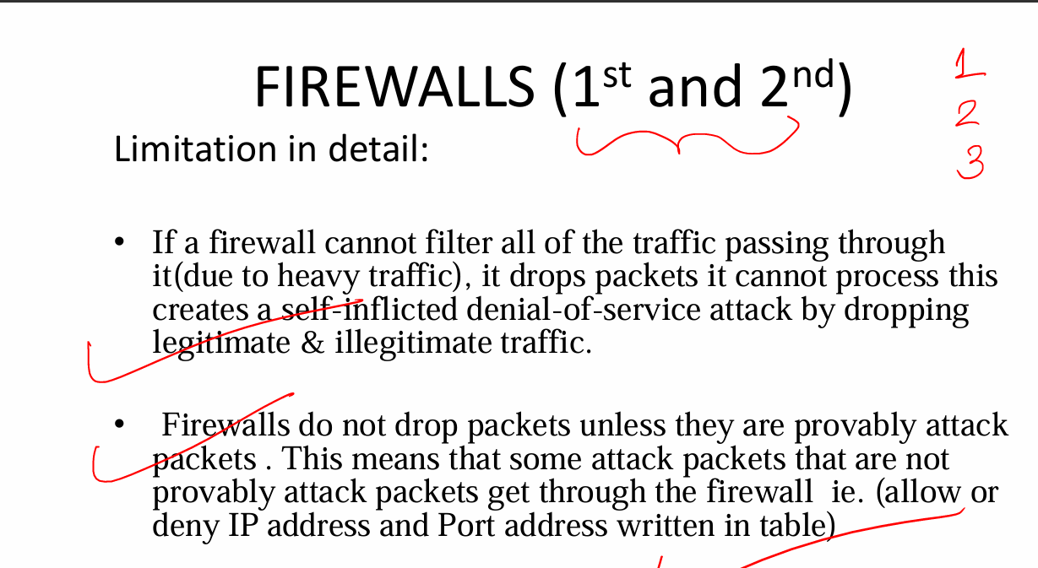 B)Application Layer Firewall

C) Circuit Level Gateway firewall

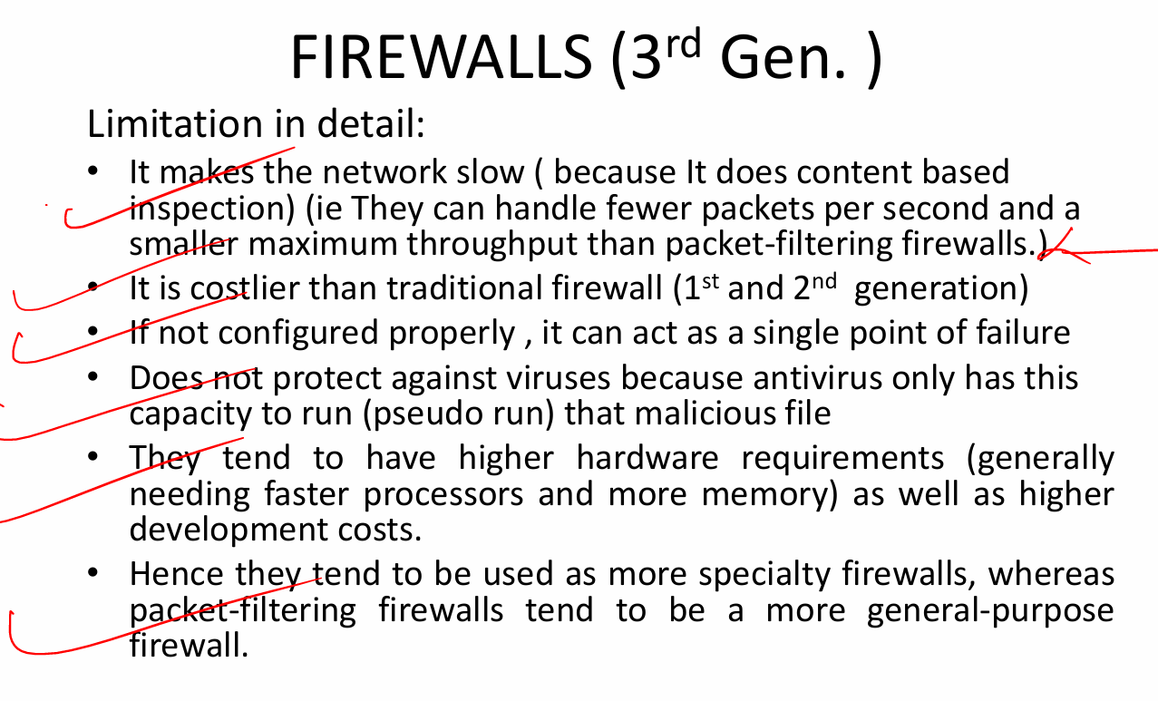

1. Compare Firewall Versus Antivirus.

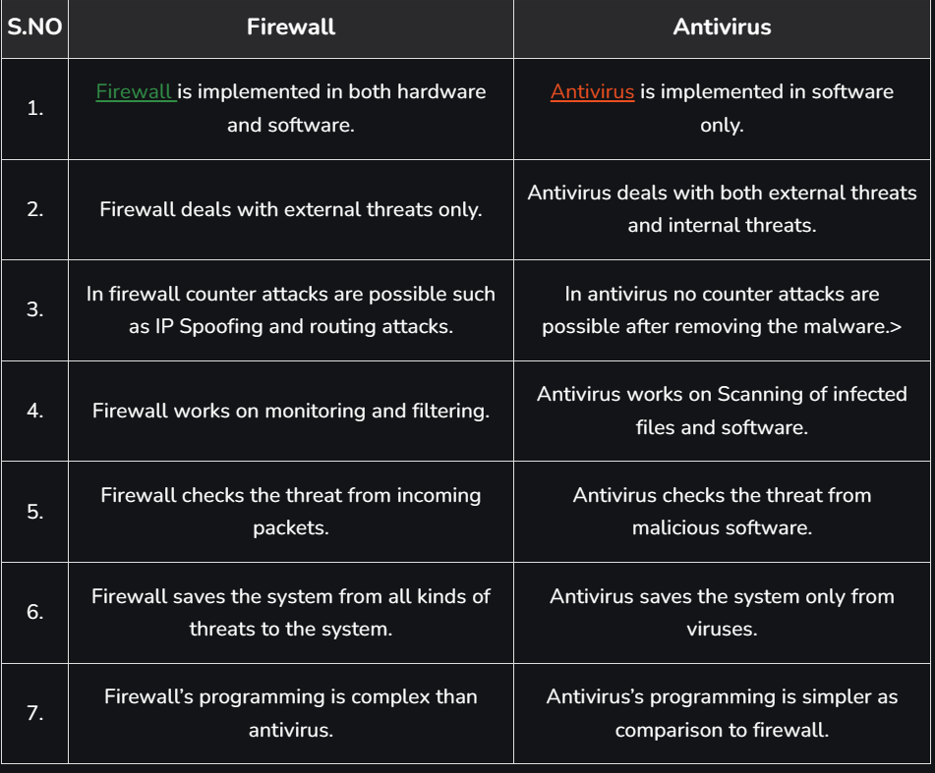

1. Compare IDS and IPS in detail.

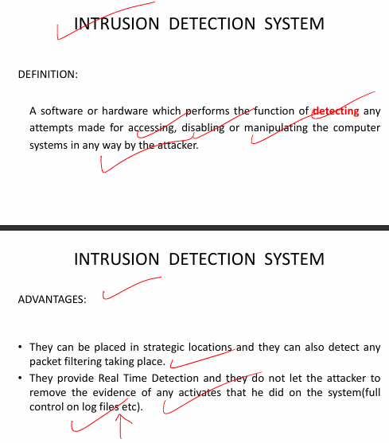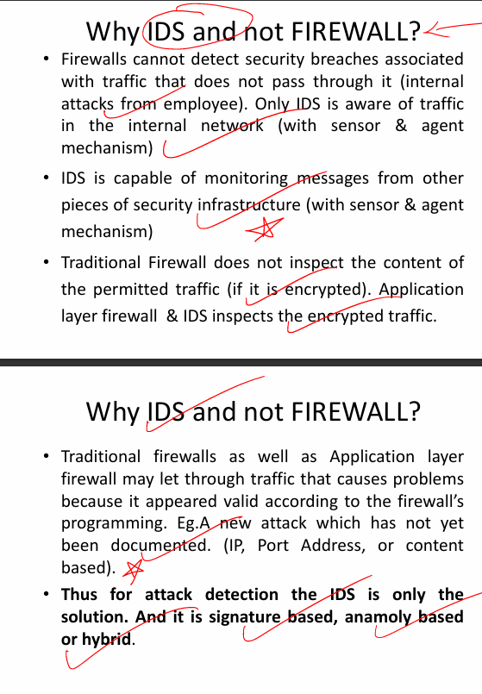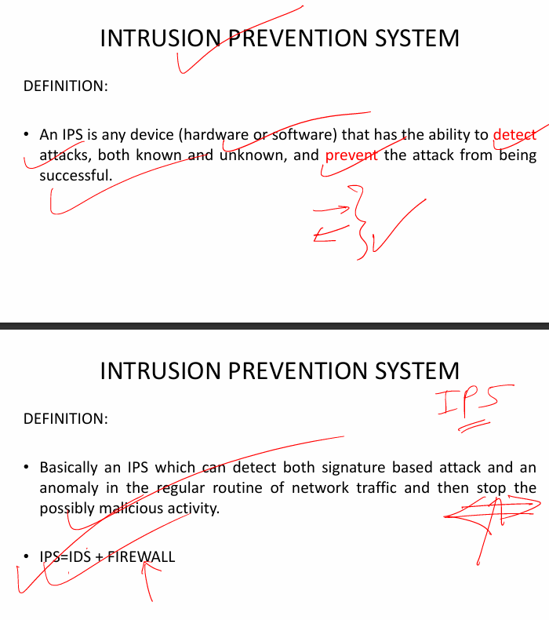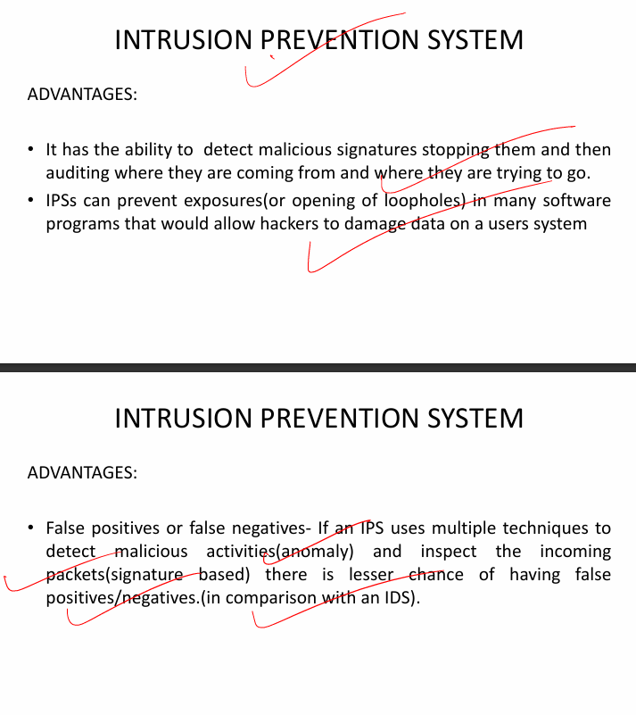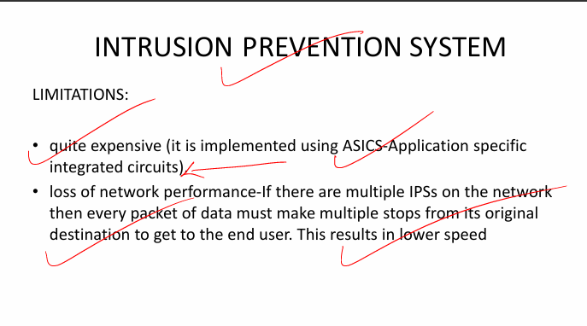

**Expt - 7**

Problem Statement - Demonstrate process to ensure Security of web browser (Google Chrome) with respect to A) Cookies settings B) Website Blocking C) Phrase/Word blocking. Explain the different features and record the different working snapshots for the same.

1. What are different types of cookies?
2. What are advantages and drawback of cookies?
3. Explain “Session Hijacking” by misusing cookies information.
4. Explain TLS and S/MIME used in Email Security. Compare PGP Vs S/MIME.

**Expt-8**

Problem Statement - Implement Hash function technique for secured network using Suitable Hashing tool and Validate using available online tools/Website tools. Explain the different features and record the different working snapshots for the same.

1. Explain following applications of Hash functions in detail
2. Protection to password storage
3. Data Integrity check
4. What is Hash function? Explain How it works briefly? List the different applications of SHA2.

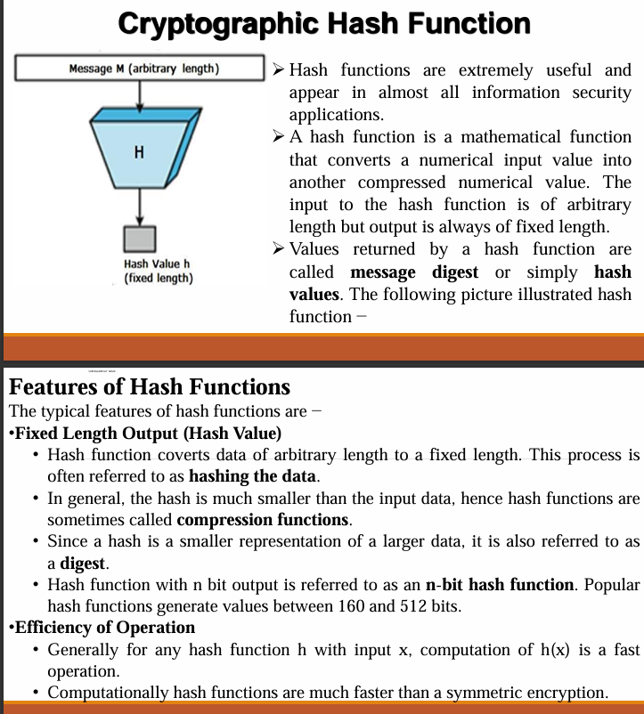

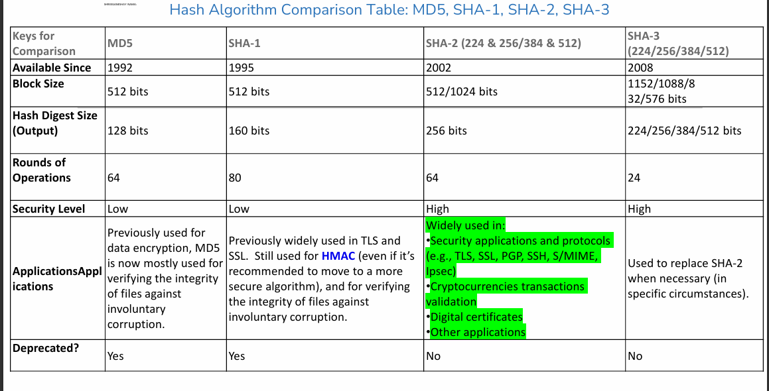

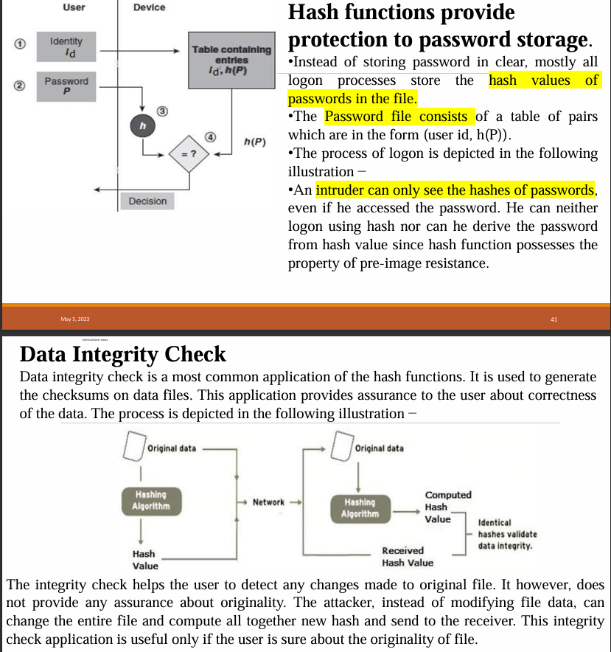

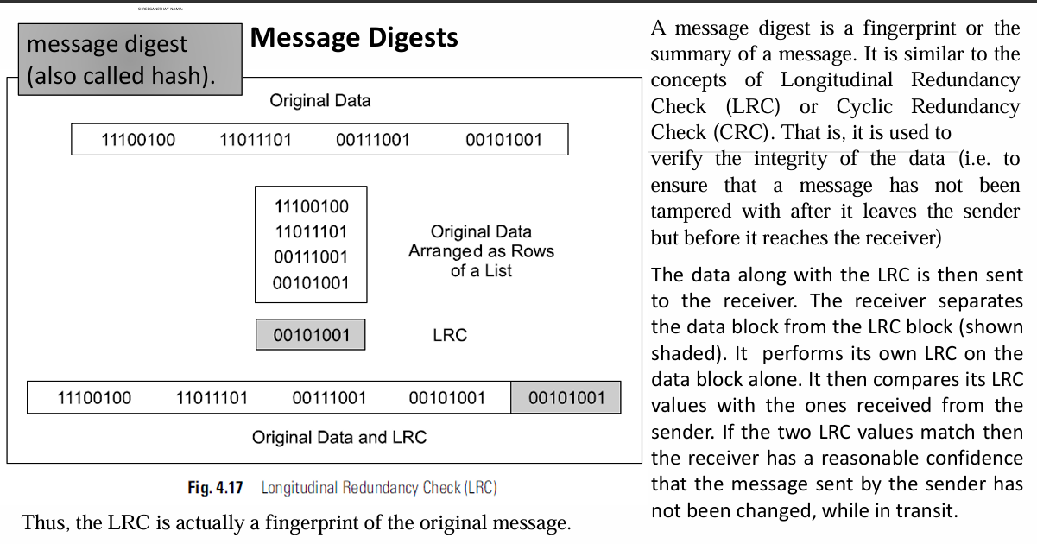

**Expt -9**

Problem Statement - Simulate Diffie-Hellman secure key exchange protocol using Vlabs simulation tool. Explain the different features of above protocol and record the different working snapshots for the same.

1. Write short note on the following
2. Transport and tunnel mode in IPSec.
3. S/MIME for Email security.
4. TLS explanation with Suitable example

**Expt - 10**

Problem Statement - Simulate Vernam Cipher for encryption and decryption using Vlabs simulation tool. Explain the different features of above technique with suitable example and record the different working snapshots for the same.

30.Explain AH and ESP working in IPSec.

MAC

